CS 38000 Artificial Intelligence **Amir Mohideen**

**Assignment 03**

(Assignment 03 is the continuation of Assignments 01 and 02) Total Points: 100

Due on Thursday March 26, 2020 in class. No late assignment is acceptable.

Consider a problem of designing an intelligent agent called the maze-problem-solver (assuming the solver is a mice). We will assume that the mice have two eyes (a sensor) and four legs (an actuator).

Given ANY maze configuration (full of grids, each grid has walls on its sides or opens on its sides). An example of a type of the grids is as follows: which has two walls and two opens.

a grid

wall

open

An example of a grid has an exit or entrance is as follows.

exit

a grid

wall

open

The maze has an entrance (equivalently, called the initial state) for entering the maze, and two exits ( **] [** ) (or called final states). The maze-problem-solver can find its ways from entrance to an exit ( **] [** ) by traversing through grids. The goal is that the maze-problem-solver enters the given maze and exit from the maze with minimal time span (e.g., the minimal path cost which is measured in terms of number of direction-turns and number of **grids** traversed by the maze-problem-solver from the initial state through the goal states).

Given ANY maze configuration, for formulating the problem as a search problem, you require the following components for the maze-problem-solver. In Assignments 01and 02, given ANY maze configuration, for formulating the problem as a search problem, you are required to describe the maze-problem solver into four areas (I through IV):

Describe the maze-problem solver as:

1. Identify and formulate the initial state, goal states, and goal test that best represents the starting conditions, the condition for the goal and the condition for checking the goal reached, i.e., the maze-problem solver wants to achieve.
2. Initial state
3. Goal state
4. Goal test? A goal test, can be (but not necessary these descriptions)
   * 1. explicit, [In(G), Exit(G)]
     2. implicit, Checkmate(x.equals([In(G), Exit(G)]))
5. Solution cost (e.g., path cost, total number of grids the agent traversed through

and number of times it turns the direction toward the open exit).

States: In (mouse’s forward side, mouse’s right side, mouse’s back side, mouse’s left side)

Entry or Exit is 0; Wall is 1; No wall is 2

So,

1. Initial state – In (2, 2, 0, 1)
2. Goal state – At(g), In (0, 1, 2, 2)

At(G), In (2, 1, 0, 1)

1. Goal Test – Check if state equal to In (0, 1, 2, 2) or In (2, 1, 0, 1)
2. Solution Cost -

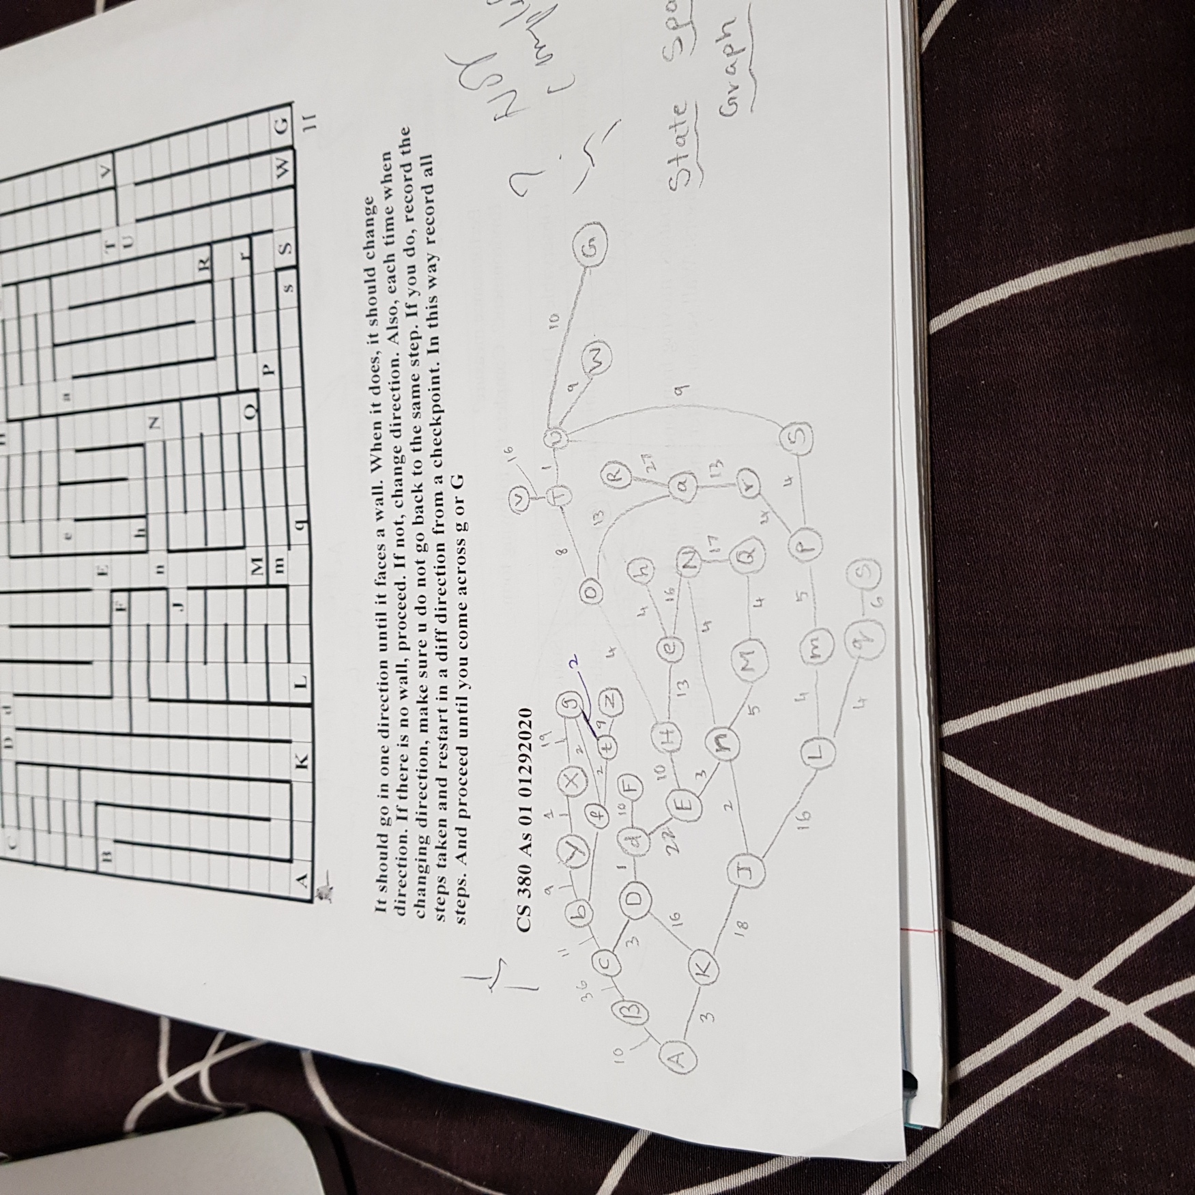



1. Identify and formulate all required states over which the solver performs an action adopted. The description of a state is a way for representing in a computer the states of the real problem.

States? (Hint: specify all the state’s types for every different grid’s types, required

for this problem. All the alphabetical symbols should not be used in

your program. Furthermore, function SIMPLE_REFLE_AGENT

has a statement: state $←$ INTERPRET_INPUT(percept). The specification

of the States should be done for the input of your program. It should not

specify in terms of alphabets).

States: In (mouse’s forward side, mouse’s right side, mouse’s back side, mouse’s left side)

Entry or Exit is 0; Wall is 1; No wall is 2

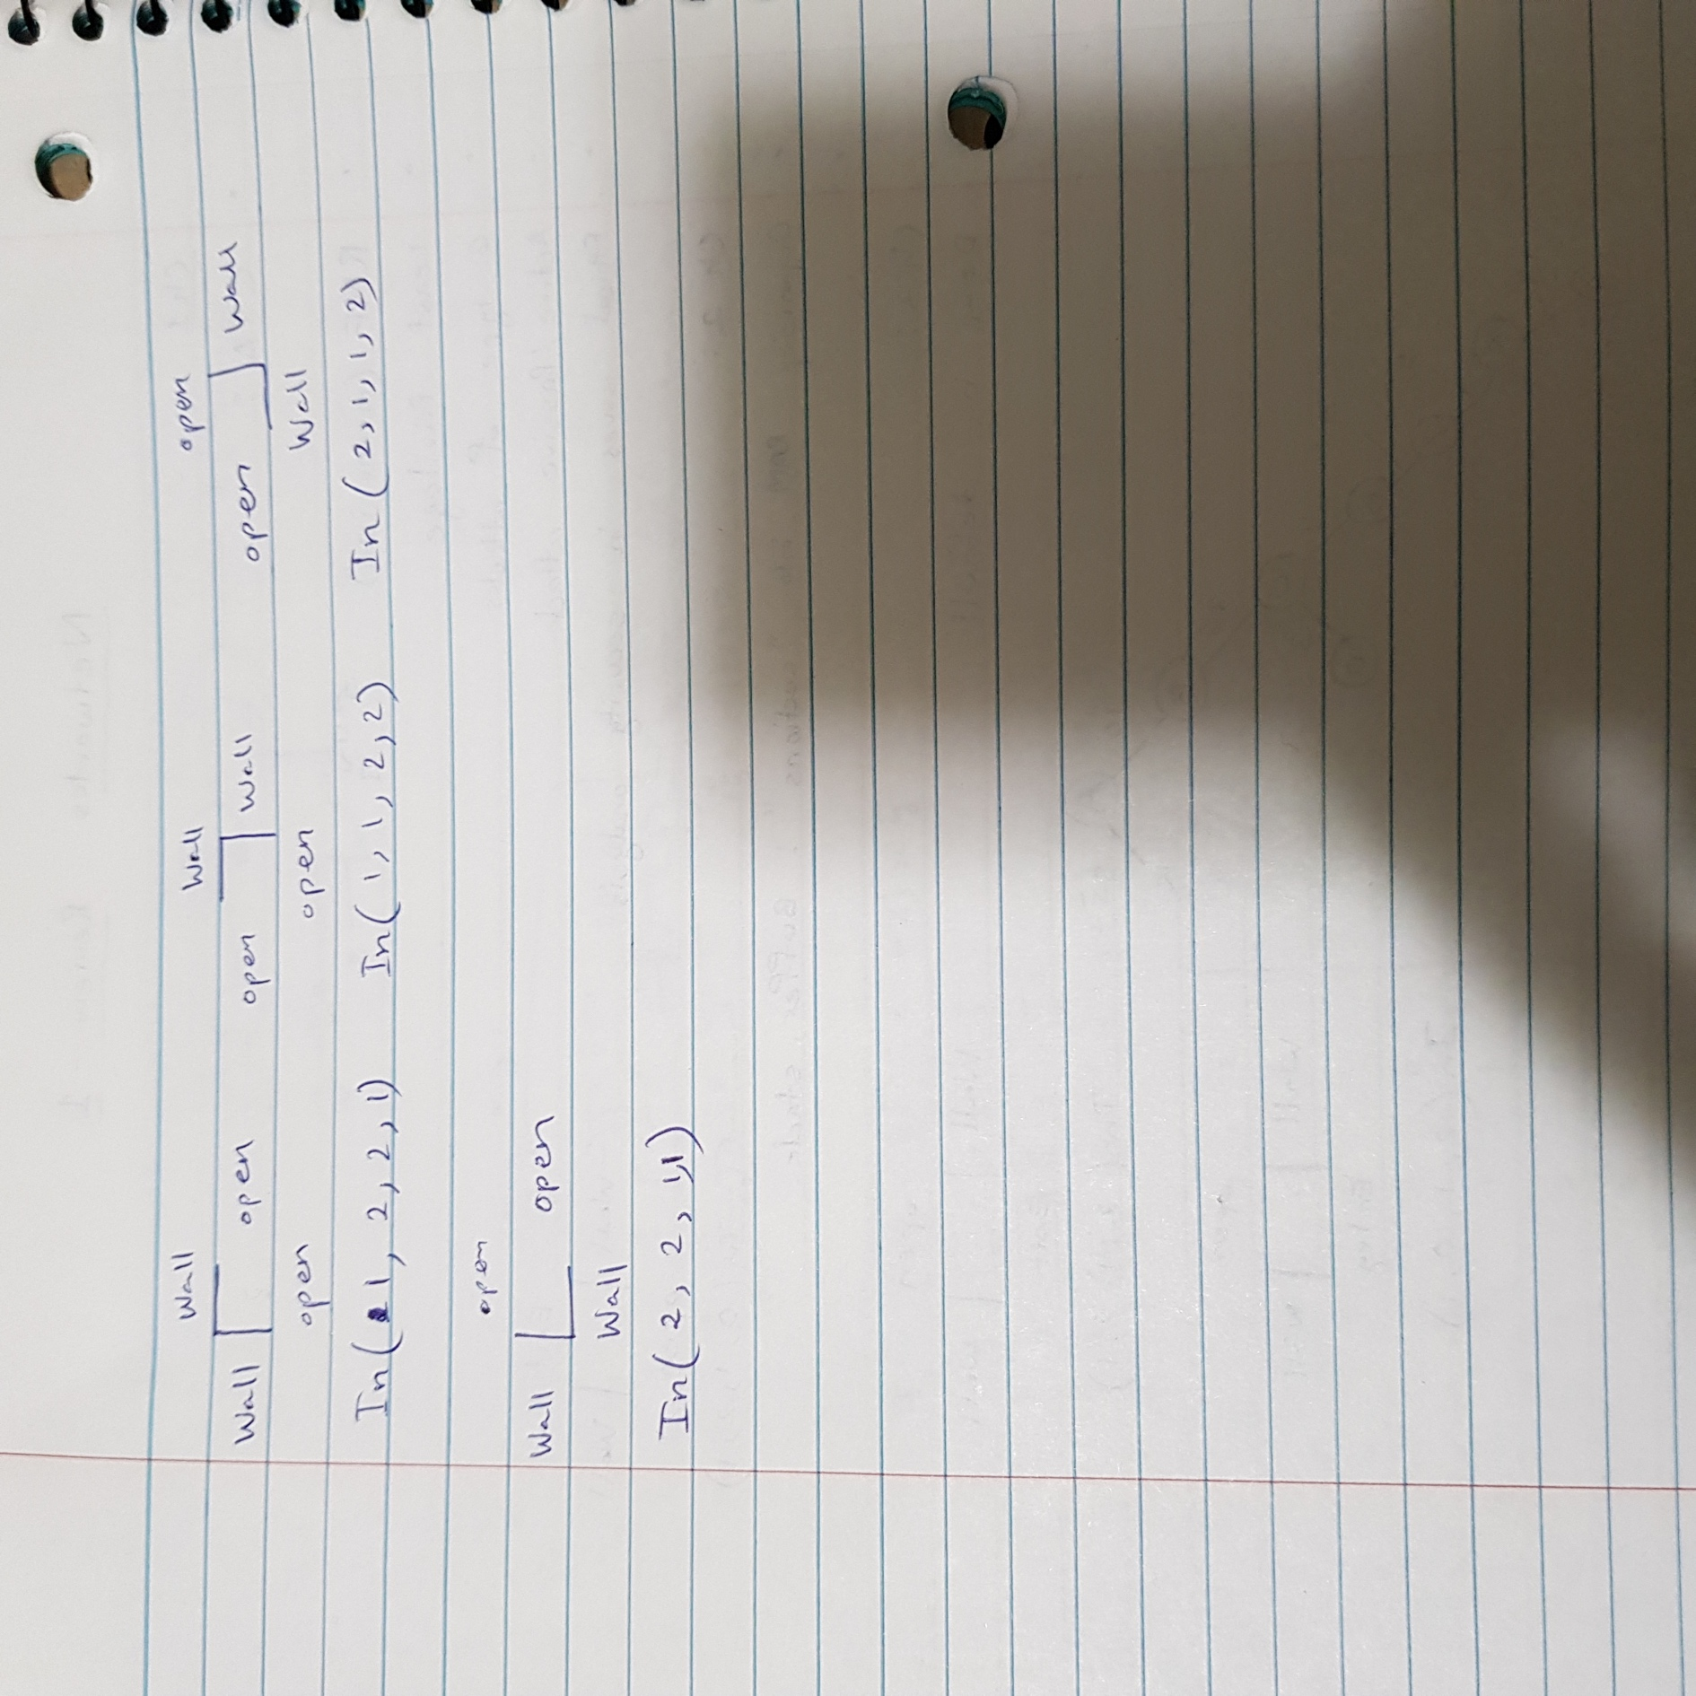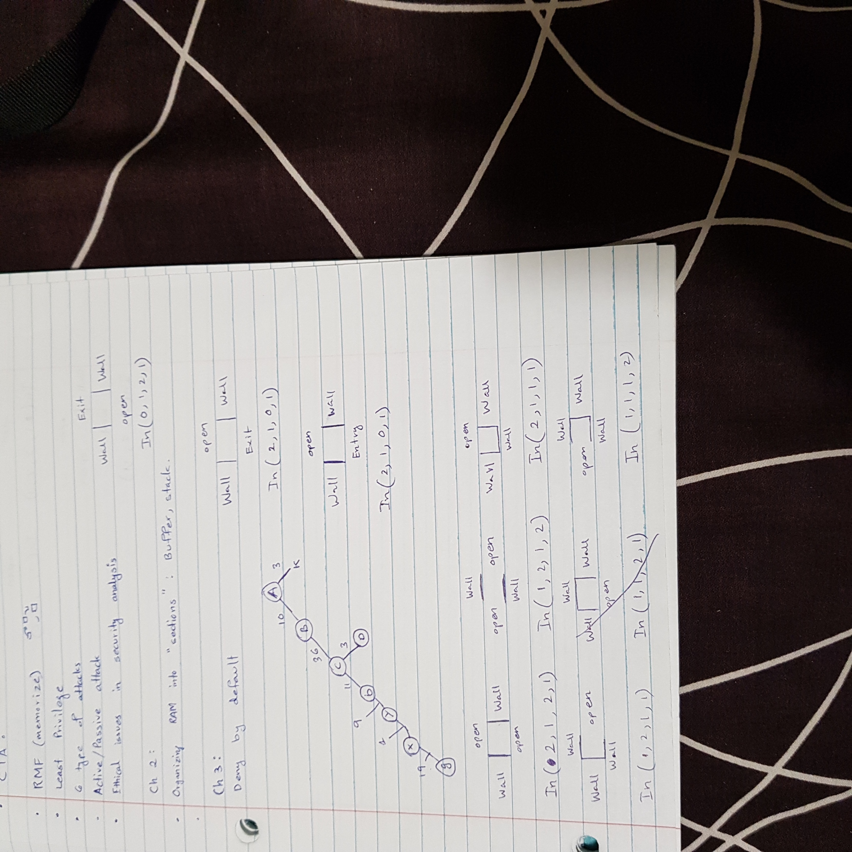

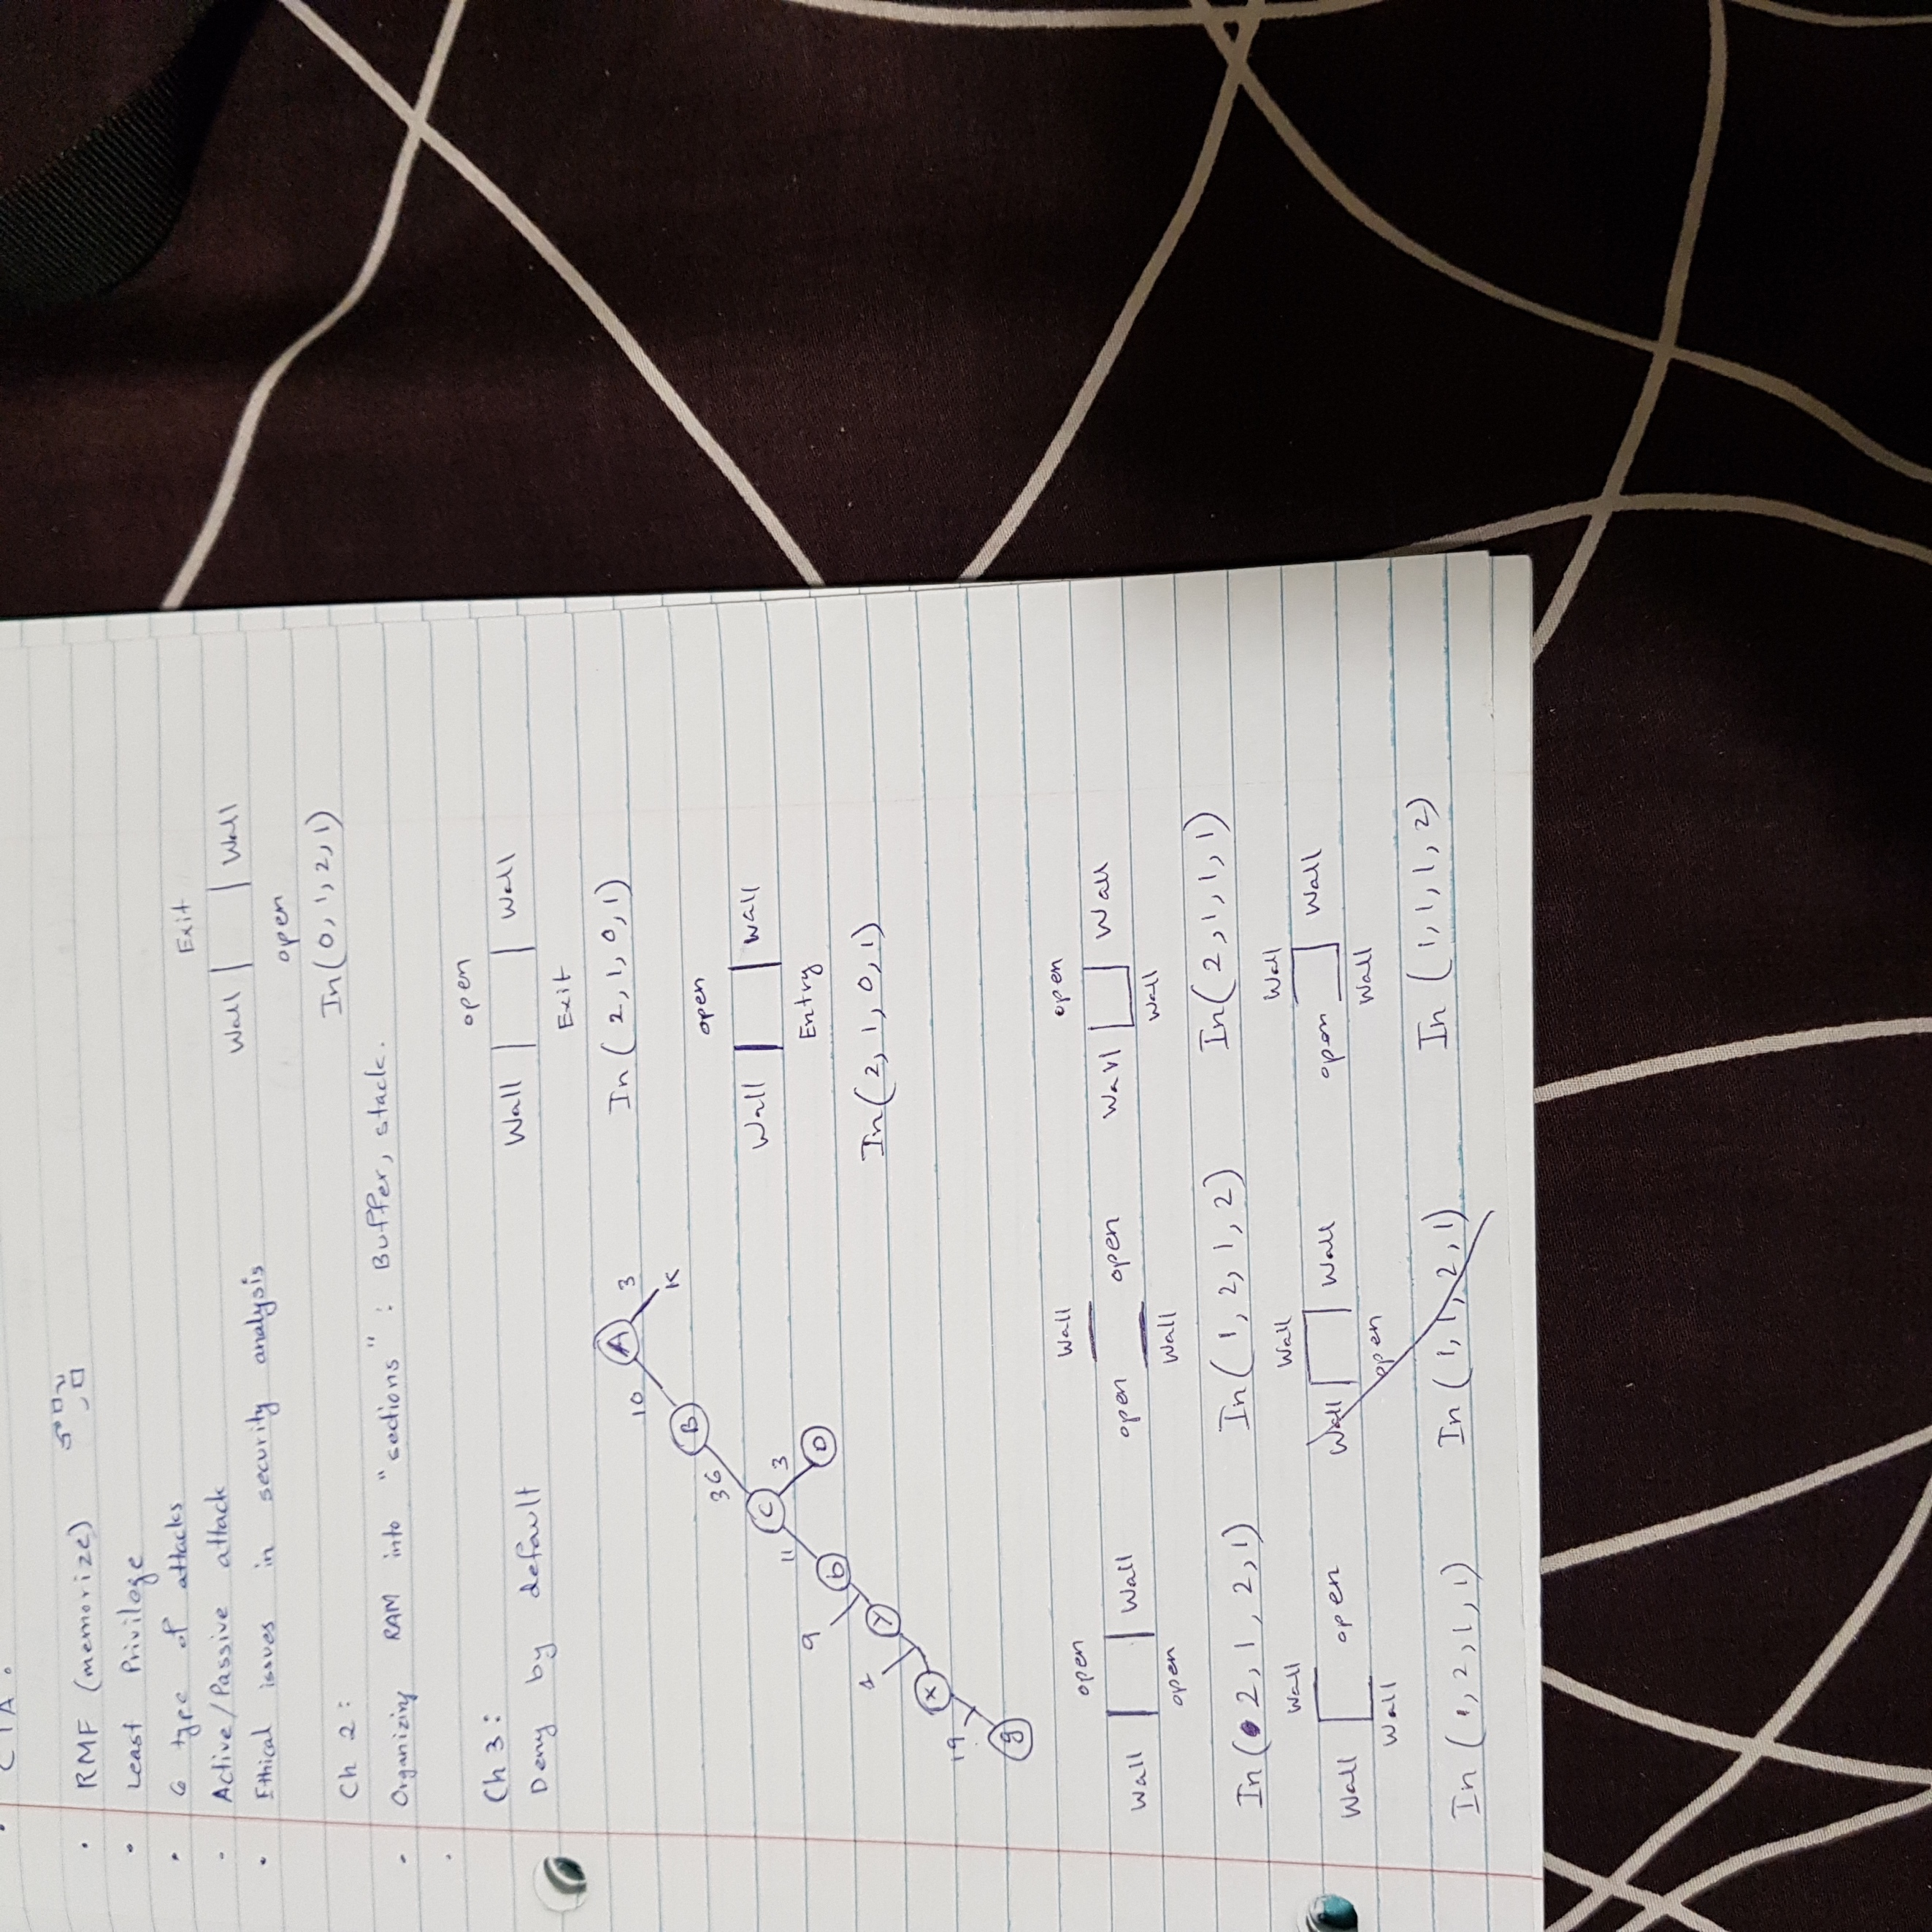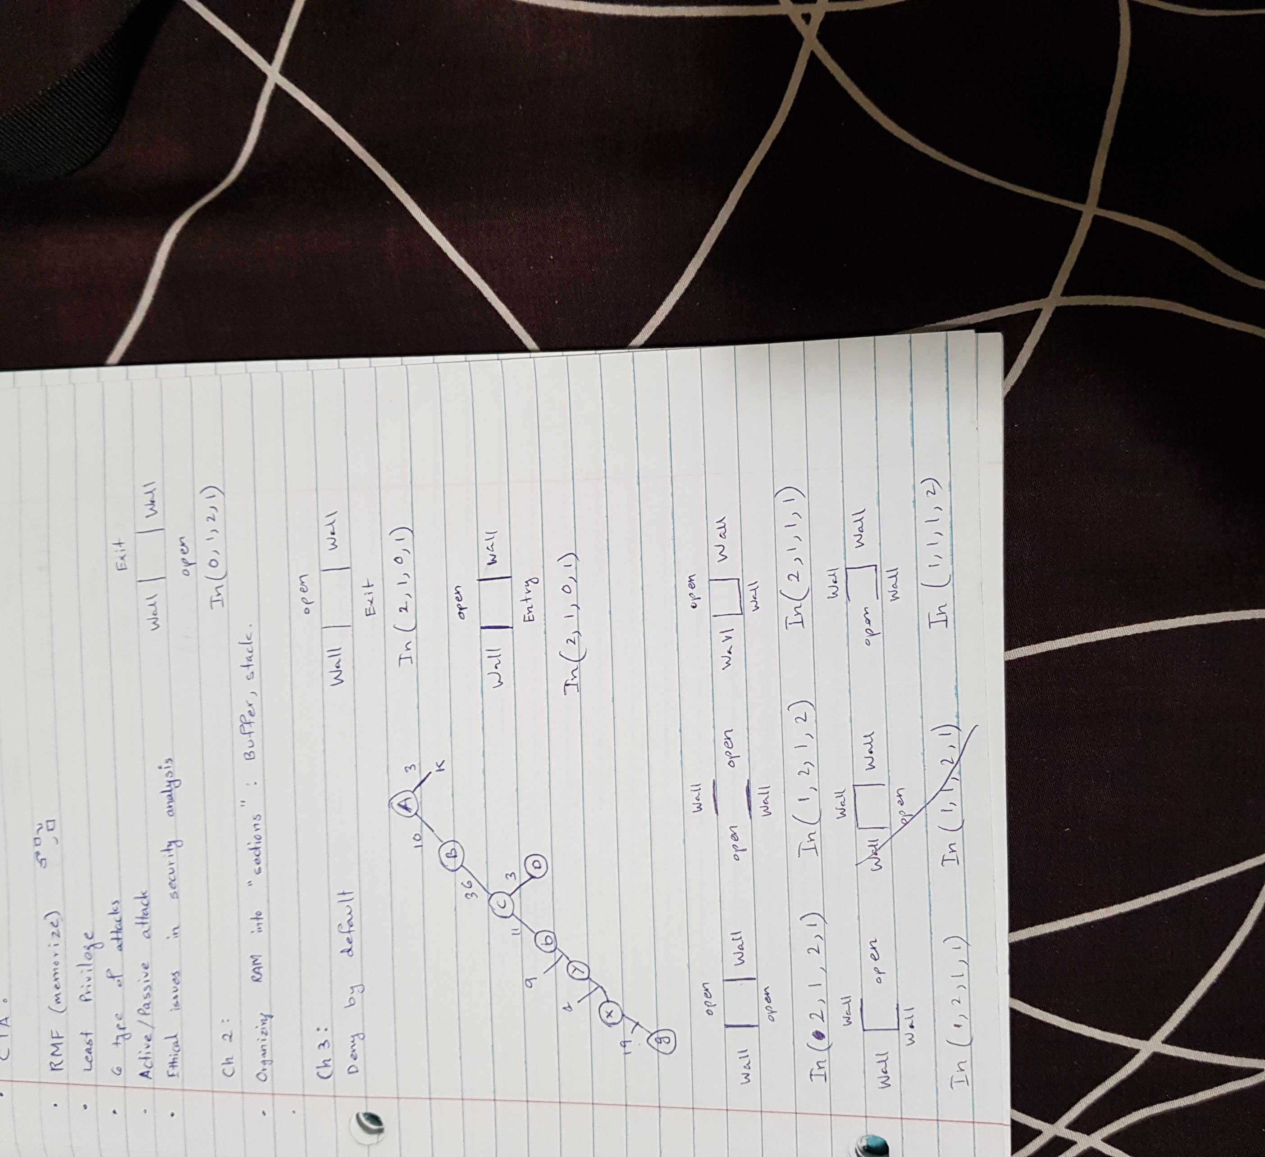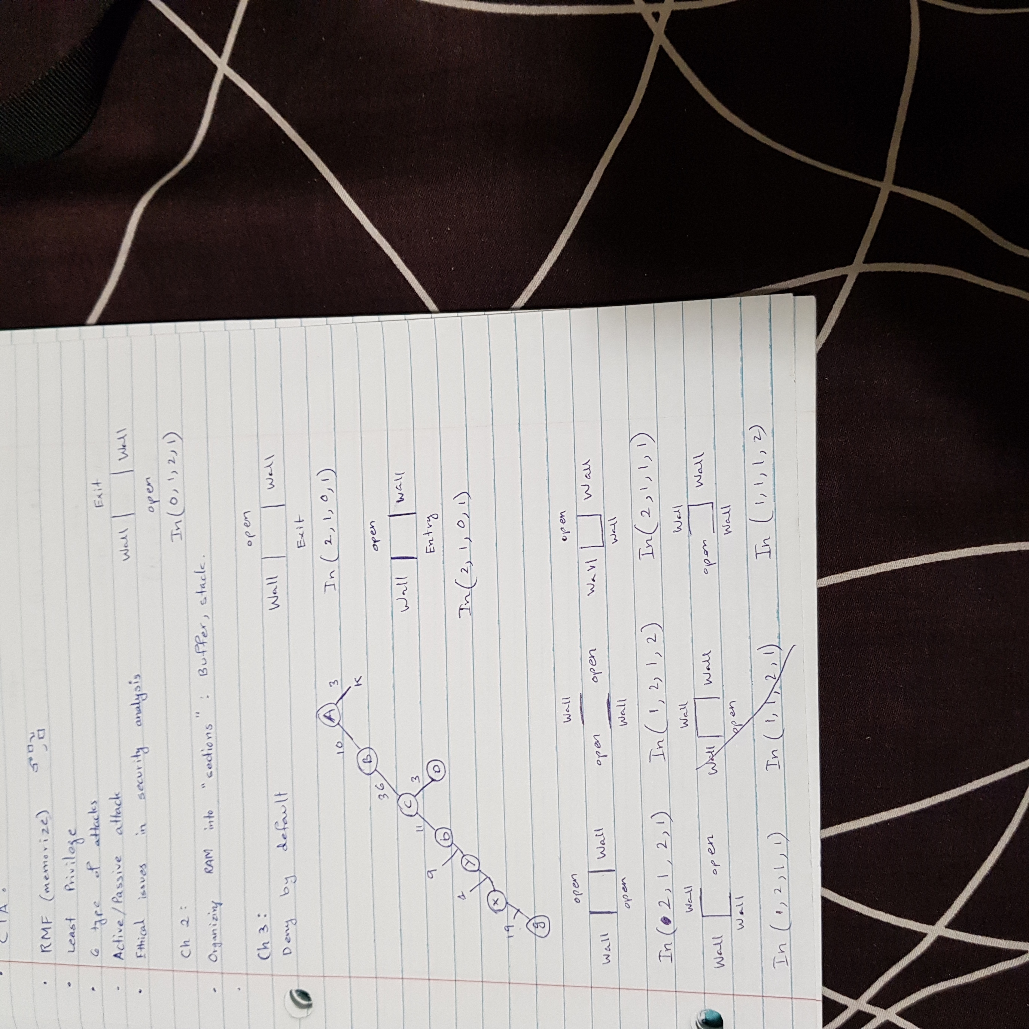

1. One of the input to your program is any given maze, which can be described in terms of graph (or called it as the state space graph). For example, in the previous assignments, you may draw a node A and another node B, connecting an edge with weight 10 (grids in distance). For each node of the graph, there is an associated state.

This state space is a graph or tree, which has information for the grids, etc. For example, the initial state has an edge to another state which is the next grid with walls on two sides, and opens on the other two sides. Then, at this state, you need a loop-edge, which describe the solver traversing the 8 remaining grips for a sequence of actions “move forward one grid”, and finally move forward to the grid B. etc.

The problem here is that the problem-solver (the mice) does not recognize any alphabets, except that its sensor produces “percept” of the environment. We can assume that one grid for a percept.

Note that you are required to formulate and specify a space which is a way for representing in a computer the states and sequences of transitions (actions) of the real problem.

What are the types of action do you need, such as move forward one grid (F), move left one grid (L), or move right one grid (R)? Give a state space which describes that the solver could perform action(s) at each grid of the maze searching for a goal state.

Action’s Types:

moveForward (In (X1, X2, X3, X4), no. of grids, In (Y1, Y2, X1, Y4))

TurnRight (In (X1, X2, X3, X4), 0 , In (X2, X3, X4, X1))

TurnLeft (In (X1, X2, X3, X4), 0 , In (X4, X1, X2, X3))

Specify State Spaces graph for ANY given maze?

(Hint: specify all the types of state for different types of grid,

required for this problem, and then convert it in a specification that

could be used as input to your program. ).

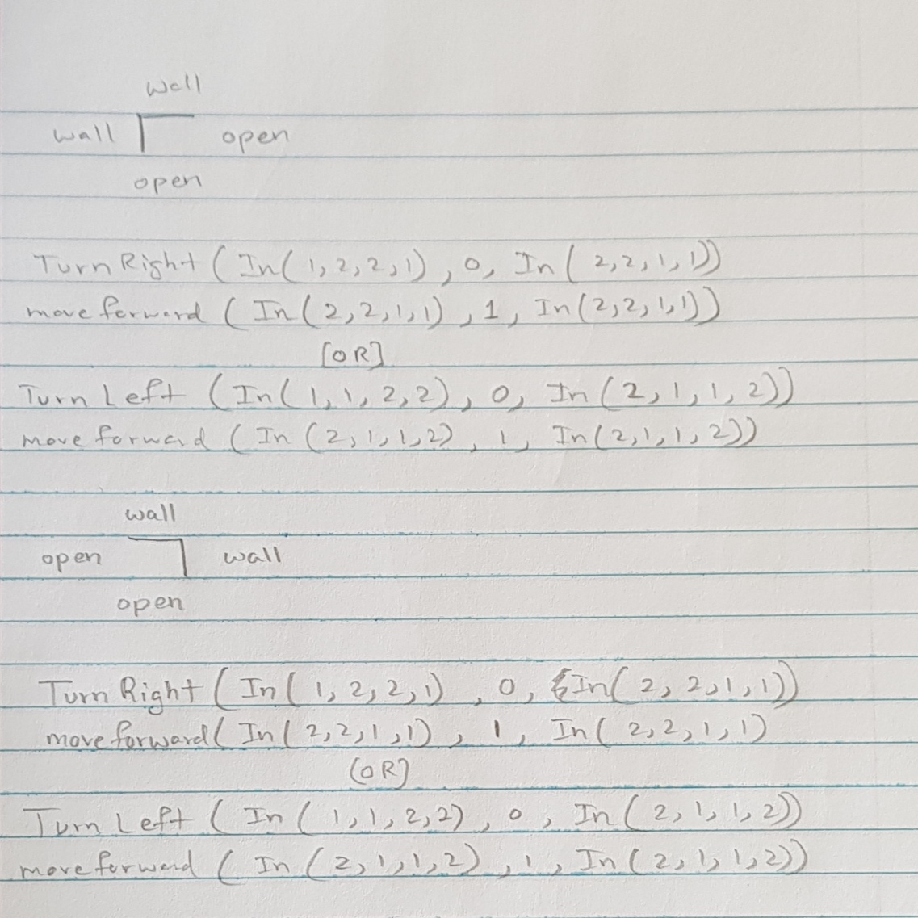

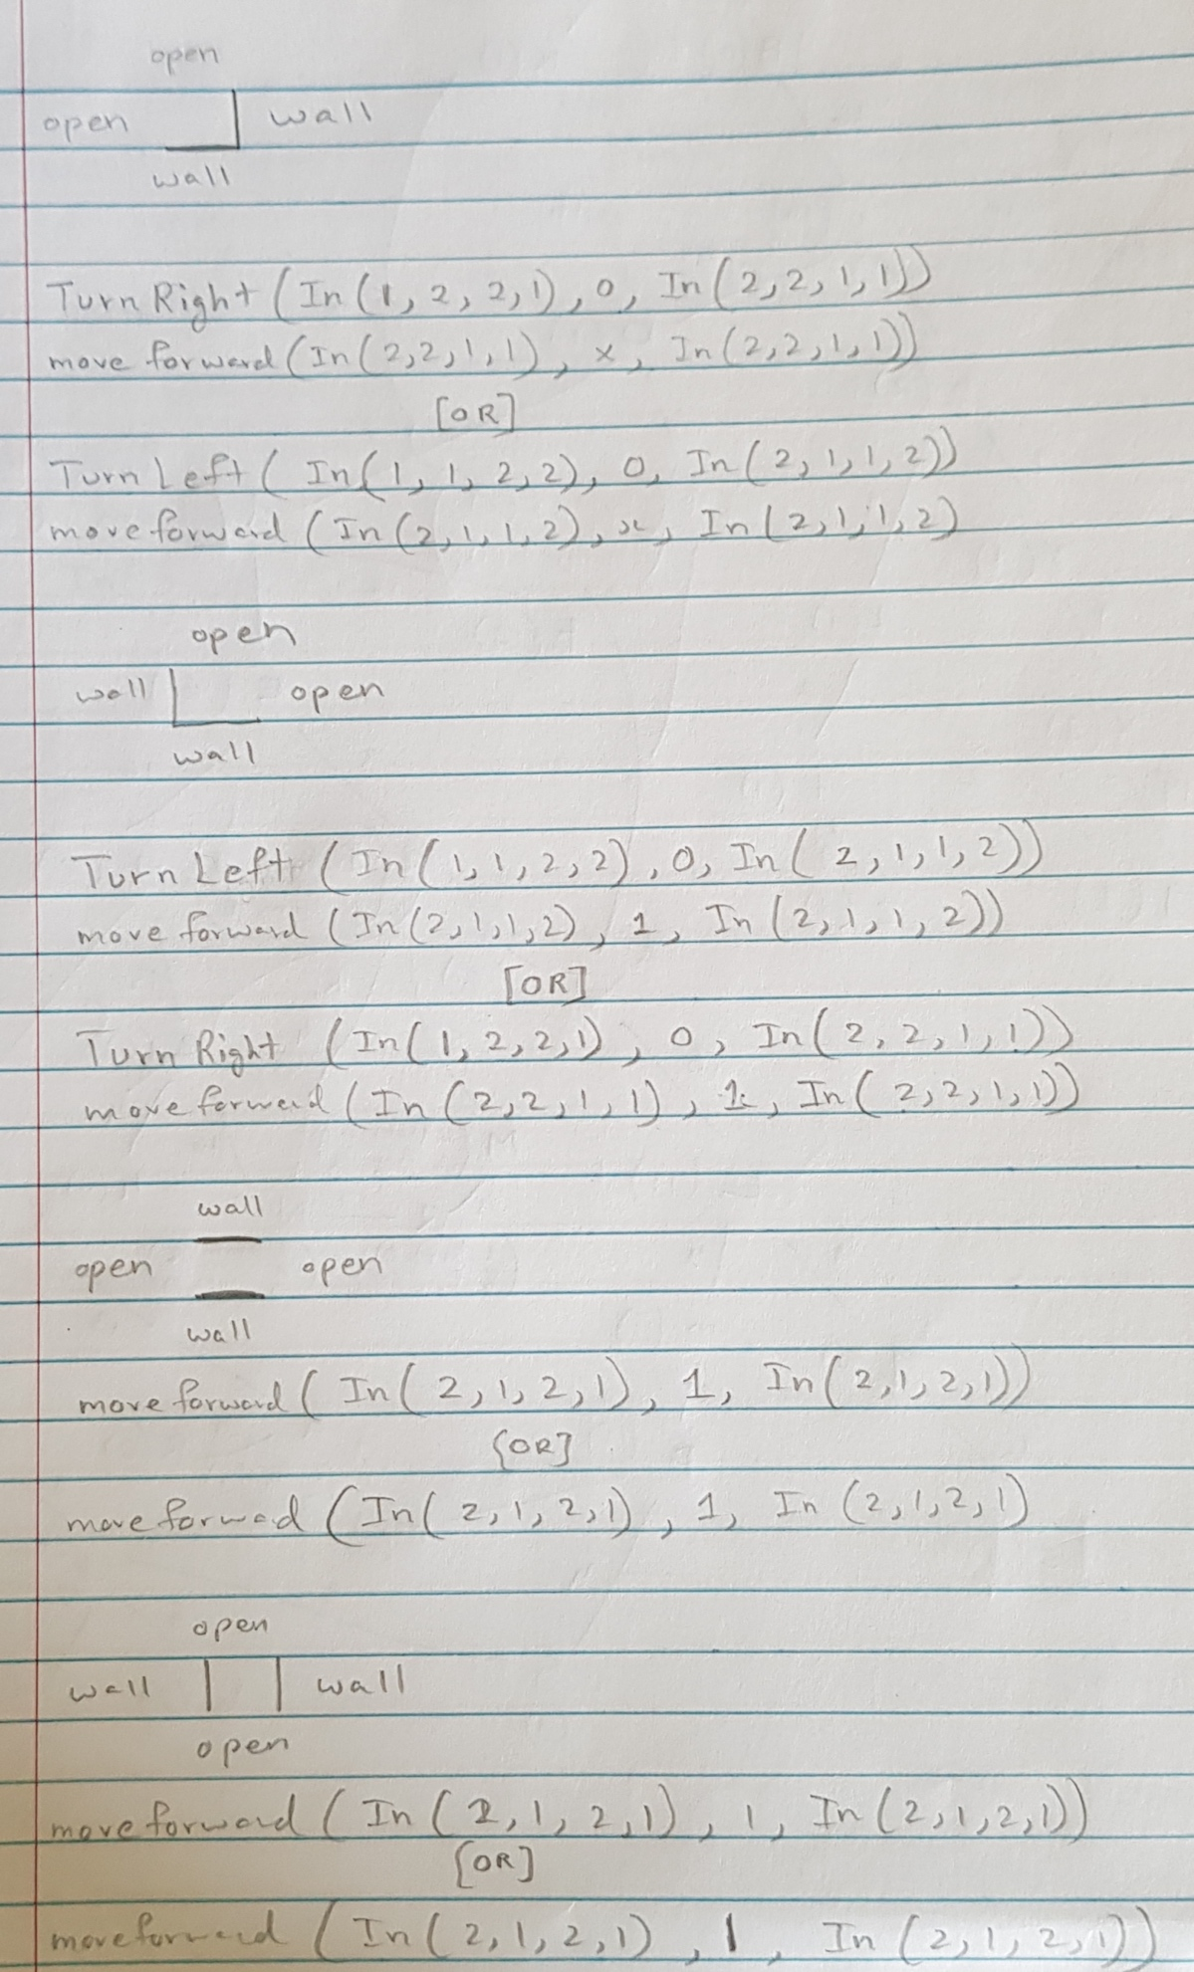

1. For all the action’s types you have used in III, formulate actions or state space transitions that allow the solver to move between different states. These actions reflect the actions one can take in the real problem but operate on the state space instead. After a list of actions is acquired, you may specify all the required successor functions for this maze-problem solver.

A successor function (Operator/action) *S(x)* = sets of (action, state) pairs. At the state *x*, either the solver takes an action to reach the next state. It is often that at the state *x*, the solver may have multiple choices of action take can be taken.

For this maze-problem-solver (also called the solver or agent), it is required to define successor functions (operators/actions) allows the agent moving forward one grid, moving right one grid or moving left on grid, based on the current state of the current grid and the next state determined by the next action if adopted.

In brief, what is the transition that takes a sequence of actions from one state to another state according the actions, one action at a time.

moveForward (In (X1, X2, X3, X4), no. of grids, In (Y1, Y2, X1, Y4))

TurnRight (In (X1, X2, X3, X4), 0 , In (X2, X3, X4, X1))

TurnLeft (In (X1, X2, X3, X4), 0 , In (X4, X1, X2, X3))

1. Using the resultant initial state, goal states, states, actions (transitions), obtained in I through VI, and others, construct a search space (which can be represented in terms of graph or tree) for this problem.

Search Space?

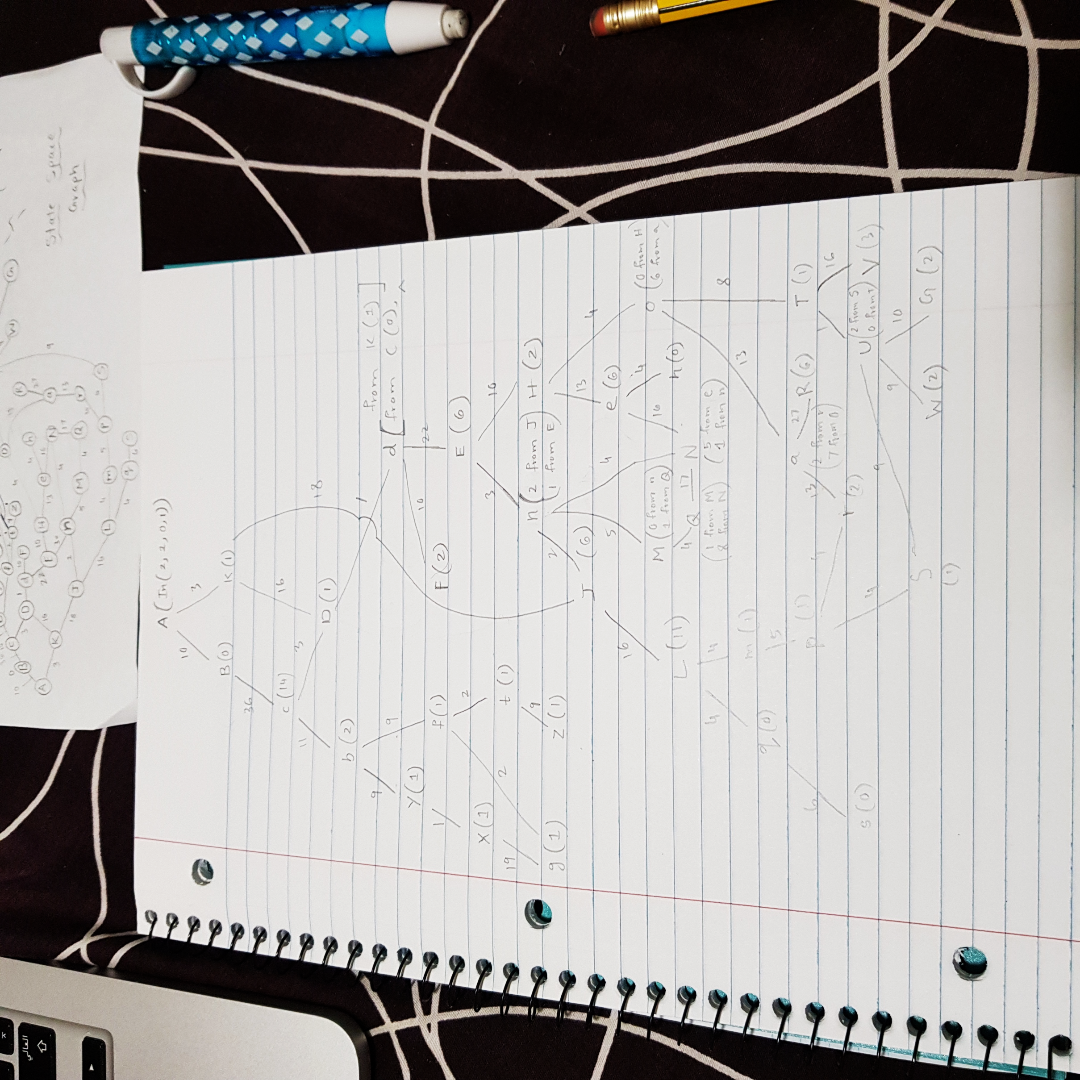

Your program should be allowed using different search strategies for finding the goal state from a given initial state. Put it another words, you should run your program separately using breadth-first search, uniformed cost search, and depth-limit search.

Each of these separate runs has its output of a search tree which shows the problem-solver traversal for searching one of the given goal states.

Discuss their search strategies time and space efficiencies based on your output data.

Using the same program that you have, create a newly different maze as your input. Run the same three search strategies. Output their search trees. What are their time and space efficiencies based on your output data.

**Submit the code of your program (past it in Word .docx file) with input data, search strategy, output data and your discussion, comments, description.**

**The following graph is a maze example: Assume A is the entrance. G and g are exits.**

**] [**

**] [**

|  |  |  |  |  |  |  |  |  |  |  |  |  |  |  |  |  |  |  |  |
| --- | --- | --- | --- | --- | --- | --- | --- | --- | --- | --- | --- | --- | --- | --- | --- | --- | --- | --- | --- |
| **X** |  |  |  |  |  |  |  |  |  |  |  |  |  |  |  |  |  |  | **g** |
| **Y** |  |  |  |  |  |  |  |  | **b** |  |  |  |  |  |  |  |  | **f** |  |
|  |  |  |  |  |  |  |  |  |  | **Z** |  |  |  |  |  |  |  |  | **t** |
| **C** |  |  | **D** | **d** |  |  |  |  |  |  |  | **H** |  |  |  | **O** |  |  |  |
|  |  |  |  |  |  |  |  |  |  |  |  |  |  |  |  |  |  |  |  |
|  |  |  |  |  |  |  |  |  |  |  |  |  |  |  |  |  |  |  |  |
|  |  |  |  |  |  |  |  |  |  |  |  |  |  |  |  |  |  |  |  |
|  |  |  |  |  |  |  |  |  | **e** |  |  |  | **a** |  |  |  |  |  |  |
|  |  |  |  |  |  |  |  |  |  |  |  |  |  |  |  |  |  |  |  |
| **B** |  |  |  |  |  |  |  | **E** |  |  |  |  |  |  |  |  |  |  |  |
|  |  |  |  |  |  |  | **F** |  |  |  |  |  |  |  |  |  | **T** |  | **V** |
|  |  |  |  |  |  |  |  |  | **h** |  |  |  |  |  |  |  | **U** |  |  |
|  |  |  |  |  |  |  |  | **n** |  |  |  | **N** |  |  |  |  |  |  |  |
|  |  |  |  |  |  |  | **J** |  |  |  |  |  |  |  |  |  |  |  |  |
|  |  |  |  |  |  |  |  |  |  |  |  |  |  |  |  |  |  |  |  |
|  |  |  |  |  |  |  |  |  |  |  |  |  |  |  |  | **R** |  |  |  |
|  |  |  |  |  |  |  |  |  |  |  |  |  |  |  |  |  |  |  |  |
|  |  |  |  |  |  |  |  | **M** |  |  |  | **Q** |  |  |  | **r** |  |  |  |
|  |  |  |  |  |  |  |  | **m** |  |  |  |  | **P** |  |  |  |  |  |  |
| **A** |  |  | **K** |  | **L** |  |  |  | **q** |  |  |  |  |  | **s** | **S** |  | **W** | **G** |

**] [**

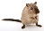

CS 380 As 03 03032020

Output data with comments and decriptions

Given any maze

(specification)

Apply any Search strategy

If works

A problem-solver

(a witten program)

**Solutions:**

1. **Breadth First Search**

**Input:**

Maze 2-

S 0 1 0 0

0 0 0 0 0

0 0 0 1 0

1 1 0 1 1

0 0 0 0 E

This is a maze without alphabets where, 0 represents a path, 1 represents a wall, S represents the start position and E represents the exit of the maze.

**Code:**

import java.util.*;

import java.lang.*;

import java.io.*;

/* Name of the class has to be "Main" only if the class is public. */

class Ideone

{

static public int shortestDistance(int[][] maze, int[] start, int[] dest) {

int[][] distance = new int[maze.length][maze[0].length];

for (int[] row: distance)

Arrays.fill(row, Integer.MAX_VALUE);

distance[start[0]][start[1]] = 0;

int[][] dirs={{0, 1} ,{0, -1}, {-1, 0}, {1, 0}};

Queue < int[] > queue = new LinkedList < > ();

queue.add(start);

while (!queue.isEmpty()) {

int[] s = queue.remove();

for (int[] dir: dirs) {

int x = s[0] + dir[0];

int y = s[1] + dir[1];

int count = 0;

while (x >= 0 && y >= 0 && x < maze.length && y < maze[0].length && maze[x][y] == 0) {

x += dir[0];

y += dir[1];

count++;

}

if (distance[s[0]][s[1]] + count < distance[x - dir[0]][y - dir[1]]) {

distance[x - dir[0]][y - dir[1]] = distance[s[0]][s[1]] + count;

queue.add(new int[] {x - dir[0], y - dir[1]});

}

}

}

return distance[dest[0]][dest[1]] == Integer.MAX_VALUE ? -1 : distance[dest[0]][dest[1]];

}

public static void main(String[] args)

{

int[][] m = { {0,0,1,0,0},{0,0,0,0,0},{0,0,0,1,0},{1,1,0,1,1},{0,0,0,0,0} };

int[] k = {0, 0};

int[] j = {4, 4};

System.out.print("Cost = ");

System.out.println(shortestDistance(m,k,j));

}

}

**Output:**

Cost = 8

**Discussion:**

* The time complexity of this program can be said as O (row of maze*column of maze*maximum depth of row and column). For every node chosen, there is a maximum depth of row and column the program can traverse for a search. Whichever is the maximum, it will be included in the calculation of the time complexity.
* Space complexity: The space complexity of this program can be said as O (row of maze* row of column) since the queue has the possibility of growing upto row*column in the worst case.

1. **Uniform Cost Search:**

**Input:**

Maze 2-

S 0 1 0 0

0 0 0 0 0

0 0 0 1 0

1 1 0 1 1

0 0 0 0 E

This is a maze without alphabets where, 0 represents a path, 1 represents a wall, S represents the start position and E represents the exit of the maze.

**Code:**

import java.util.*;

import java.lang.*;

import java.io.*;

/* Name of the class has to be "Main" only if the class is public. */

class Ideone

{

private static int[][] directions = {{-1, 0}, {1, 0}, {0, -1}, {0, 1}};

public static int shortestDistance(int[][] maze, int[] start, int[] destination) {

int rows = maze.length, cols = maze[0].length;

int s = start[0] * cols + start[1];

int target = destination[0] * cols + destination[1];

Queue<int[]> pq = new PriorityQueue<>((o1, o2) -> o1[1] - o2[1]);

boolean[] visited = new boolean[rows * cols];

// length 2 array: first element -> index (1D), 2nd element -> path cost

pq.offer(new int[]{s, 0});

// visited[s] = true;

while (!pq.isEmpty()) {

int[] curr = pq.poll();

visited[curr[0]] = true;

if (curr[0] == target) return curr[1];

int currIdx = curr[0], currCost = curr[1];

int r = currIdx / cols, c = currIdx % cols;

for (int[] direction : directions) {

int rr = r, cc = c, num = 0;

while (isValid(rr + direction[0], cc + direction[1], rows, cols, maze)) {

rr += direction[0];

cc += direction[1];

num += 1;

}

if (num == 0) continue;

int next = rr * cols + cc;

if (visited[next]) continue;

pq.offer(new int[]{next, currCost + num});

}

}

return -1;

}

private static boolean isValid(int r, int c, int rows, int cols, int[][] maze) {

return r >= 0 && r < rows && c >= 0 && c < cols && maze[r][c] == 0;

}

public static void main(String[] args)

{

int[][] m = { {0,0,1,0,0},{0,0,0,0,0},{0,0,0,1,0},{1,1,0,1,1},{0,0,0,0,0} };

int[] k = {0, 0};

int[] j = {4, 4};

System.out.print("Cost = ");

System.out.println(shortestDistance(m,k,j));

}

}**Output:**

Cost = 8

**Discussion:**

* The time complexity of this program can be said as O (number of rows of maze* number of columns of maze*logarithm of rows and columns).
* Space complexity: The space complexity of this program can be said as O (row of maze* row of column) since the queue has the possibility of growing up to row*column in the worst case.

1. **Depth limit search:**

**Input:**

Maze 2-

S 0 1 0 0

0 0 0 0 0

0 0 0 1 0

1 1 0 1 1

0 0 0 0 E

This is a maze without alphabets where, 0 represents a path, 1 represents a wall, S represents the start position and E represents the exit of the maze.

**Code:**

import java.util.*;

import java.lang.*;

import java.io.*;

/* Name of the class has to be "Main" only if the class is public. */

class Ideone

{

public static int shortestDistance(int[][] maze, int[] start, int[] dest) {

int[][] distance = new int[maze.length][maze[0].length];

for (int[] row: distance)

Arrays.fill(row, Integer.MAX_VALUE);

distance[start[0]][start[1]] = 0;

dfs(maze, start, distance);

return distance[dest[0]][dest[1]] == Integer.MAX_VALUE ? -1 : distance[dest[0]][dest[1]];

}

public static void dfs(int[][] maze, int[] start, int[][] distance) {

int[][] dirs={{0,1}, {0,-1}, {-1,0}, {1,0}};

for (int[] dir: dirs) {

int x = start[0] + dir[0];

int y = start[1] + dir[1];

int count = 0;

while (x >= 0 && y >= 0 && x < maze.length && y < maze[0].length && maze[x][y] == 0) {

x += dir[0];

y += dir[1];

count++;

}

if (distance[start[0]][start[1]] + count < distance[x - dir[0]][y - dir[1]]) {

distance [x - dir[0]][y - dir[1]] = distance [start[0]][start[1]] + count;

dfs(maze, new int[]{x - dir[0],y - dir[1]}, distance);

}

}

}

public static void main(String[] args)

{

int[][] m = { {0,0,1,0,0},{0,0,0,0,0},{0,0,0,1,0},{1,1,0,1,1},{0,0,0,0,0} };

int[] k = {0, 0};

int[] j = {4, 4};

System.out.print("Cost = ");

System.out.println(shortestDistance(m,k,j));

}

}

**Output:**

Cost = 8

**Discussion:**

* The time complexity of this program can be said as O (row of maze*column of maze*maximum depth of row and column). For every node chosen, there is a maximum depth of row and column the program can traverse for a search. The value that is the maximum will be included in the calculation of the time complexity.
* Space complexity: The space complexity of this program can be said as O (row of maze* row of column) since in the worst case, the queue has the possibility of growing up to row*column.

1. **Breadth First Search**

**Input:**

Maze-

0 S 1 0 0 0 0

0 0 0 0 0 0 0

0 0 0 1 0 0 0

1 1 0 1 1 1 1

0 0 0 0 0 0 1

0 0 0 1 1 0 1

1 1 1 0 0 0 E

This is a maze without alphabets where, 0 represents a path, 1 represents a wall, S represents the start position and E represents the exit of the maze.

**Code:**

import java.util.*;

import java.lang.*;

import java.io.*;

/* Name of the class has to be "Main" only if the class is public. */

class Ideone

{

static public int shortestDistance(int[][] maze, int[] start, int[] dest) {

int[][] distance = new int[maze.length][maze[0].length];

for (int[] row: distance)

Arrays.fill(row, Integer.MAX_VALUE);

distance[start[0]][start[1]] = 0;

dfs(maze, start, distance);

return distance[dest[0]][dest[1]] == Integer.MAX_VALUE ? -1 : distance[dest[0]][dest[1]];

}

static public void dfs(int[][] maze, int[] start, int[][] distance) {

int[][] dirs={{0,1}, {0,-1}, {-1,0}, {1,0}};

for (int[] dir: dirs) {

int x = start[0] + dir[0];

int y = start[1] + dir[1];

int count = 0;

while (x >= 0 && y >= 0 && x < maze.length && y < maze[0].length && maze[x][y] == 0) {

x += dir[0];

y += dir[1];

count++;

}

if (distance[start[0]][start[1]] + count < distance[x - dir[0]][y - dir[1]]) {

distance[x - dir[0]][y - dir[1]] = distance[start[0]][start[1]] + count;

dfs(maze, new int[]{x - dir[0],y - dir[1]}, distance);

}

}

}

public static void main(String[] args)

{

int[][] m = { {0,0,1,0,0,0,0},{0,0,0,0,0,0,0},{0,0,0,1,0,0,0},{1,1,0,1,1,1,1},{0,0,0,0,0,0,1}, {0,0,0,1,1,0,1}, {1,1,1,0,0,0,0} };

int[] k = {0, 1};

int[] j = {6, 6};

System.out.print("Cost = ");

System.out.println(shortestDistance(m,k,j));

}

}

**Output:**

Cost = 17

**Discussion:**

* The time complexity of this program can be said as O (row of maze*column of maze*maximum depth of row and column). For every node chosen, there is a maximum depth of row and column the program can traverse for a search. Whichever is the maximum, it will be included in the calculation of the time complexity.
* Space complexity: The space complexity of this program can be said as O (row of maze* row of column) since the queue has the possibility of growing upto row*column in the worst case.

1. **Uniform Cost Search:**

**Input:**

Maze-

0 S 1 0 0 0 0

0 0 0 0 0 0 0

0 0 0 1 0 0 0

1 1 0 1 1 1 1

0 0 0 0 0 0 1

0 0 0 1 1 0 1

1 1 1 0 0 0 E

This is a maze without alphabets where, 0 represents a path, 1 represents a wall, S represents the start position and E represents the exit of the maze.

**Code:**

import java.util.*;

import java.lang.*;

import java.io.*;

/* Name of the class has to be "Main" only if the class is public. */

class Ideone

{

private static int[][] directions = {{-1, 0}, {1, 0}, {0, -1}, {0, 1}};

public static int shortestDistance(int[][] maze, int[] start, int[] destination) {

int rows = maze.length, cols = maze[0].length;

int s = start[0] * cols + start[1];

int target = destination[0] * cols + destination[1];

Queue<int[]> pq = new PriorityQueue<>((o1, o2) -> o1[1] - o2[1]);

boolean[] visited = new boolean[rows * cols];

// length 2 array: first element -> index (1D), 2nd element -> path cost

pq.offer(new int[]{s, 0});

// visited[s] = true;

while (!pq.isEmpty()) {

int[] curr = pq.poll();

visited[curr[0]] = true;

if (curr[0] == target) return curr[1];

int currIdx = curr[0], currCost = curr[1];

int r = currIdx / cols, c = currIdx % cols;

for (int[] direction : directions) {

int rr = r, cc = c, num = 0;

while (isValid(rr + direction[0], cc + direction[1], rows, cols, maze)) {

rr += direction[0];

cc += direction[1];

num += 1;

}

if (num == 0) continue;

int next = rr * cols + cc;

if (visited[next]) continue;

pq.offer(new int[]{next, currCost + num});

}

}

return -1;

}

private static boolean isValid(int r, int c, int rows, int cols, int[][] maze) {

return r >= 0 && r < rows && c >= 0 && c < cols && maze[r][c] == 0;

}

public static void main(String[] args)

{

int[][] m = { {0,0,1,0,0,0,0},{0,0,0,0,0,0,0},{0,0,0,1,0,0,0},{1,1,0,1,1,1,1},{0,0,0,0,0,0,1}, {0,0,0,1,1,0,1}, {1,1,1,0,0,0,0} };

int[] k = {0, 1};

int[] j = {6, 6};

System.out.print("Cost = ");

System.out.println(shortestDistance(m,k,j));

}

}

**Output:**

Cost = 17

**Discussion:**

* The time complexity of this program can be said as O (number of rows of maze* number of columns of maze*logarithm of rows and columns).
* Space complexity: The space complexity of this program can be said as O (row of maze* row of column) since the queue has the possibility of growing up to row*column in the worst case.

1. **Depth limit search:**

**Input:**

Maze-

0 S 1 0 0 0 0

0 0 0 0 0 0 0

0 0 0 1 0 0 0

1 1 0 1 1 1 1

0 0 0 0 0 0 1

0 0 0 1 1 0 1

1 1 1 0 0 0 E

This is a maze without alphabets where, 0 represents a path, 1 represents a wall, S represents the start position and E represents the exit of the maze.

**Code:**

import java.util.*;

import java.lang.*;

import java.io.*;

/* Name of the class has to be "Main" only if the class is public. */

class Ideone

{

public static int shortestDistance(int[][] maze, int[] start, int[] dest) {

int[][] distance = new int[maze.length][maze[0].length];

for (int[] row: distance)

Arrays.fill(row, Integer.MAX_VALUE);

distance[start[0]][start[1]] = 0;

dfs(maze, start, distance);

return distance[dest[0]][dest[1]] == Integer.MAX_VALUE ? -1 : distance[dest[0]][dest[1]];

}

public static void dfs(int[][] maze, int[] start, int[][] distance) {

int[][] dirs={{0,1}, {0,-1}, {-1,0}, {1,0}};

for (int[] dir: dirs) {

int x = start[0] + dir[0];

int y = start[1] + dir[1];

int count = 0;

while (x >= 0 && y >= 0 && x < maze.length && y < maze[0].length && maze[x][y] == 0) {

x += dir[0];

y += dir[1];

count++;

}

if (distance[start[0]][start[1]] + count < distance[x - dir[0]][y - dir[1]]) {

distance[x - dir[0]][y - dir[1]] = distance[start[0]][start[1]] + count;

dfs(maze, new int[]{x - dir[0],y - dir[1]}, distance);

}

}

}

public static void main(String[] args)

{

int[][] m = { {0,0,1,0,0,0,0},{0,0,0,0,0,0,0},{0,0,0,1,0,0,0},{1,1,0,1,1,1,1},{0,0,0,0,0,0,1}, {0,0,0,1,1,0,1}, {1,1,1,0,0,0,0} };

int[] k = {0, 1};

int[] j = {6, 6};

System.out.print("Cost = ");

System.out.println(shortestDistance(m,k,j));

}

}

**Output:**

Cost = 17

**Discussion:**

* The time complexity of this program can be said as O (row of maze*column of maze*maximum depth of row and column). For every node chosen, there is a maximum depth of row and column the program can traverse for a search. The value that is the maximum will be included in the calculation of the time complexity.
* Space complexity: The space complexity of this program can be said as O (row of maze* row of column) since in the worst case, the queue has the possibility of growing up to row*column.